Example Lesson Plan #3

6-Point Lesson Plan

Subject:​ Social Studies/Science Computer Modeling & Disease

Teacher:​ Jacob Duvall Time (2 day lesson cycle)

NC Essential Standards Objective(s): 7.H.2.4 Analyze the economic, political, and social impacts of disease (e.g. smallpox, malaria, bubonic plague, AIDS and avian flu) in modern societies.

The student will know:

● The difference between a pandemic and epidemic.

● How deficiencies, environmental factors, and immunities contribute to the spread or prevention of disease.

● The impact of biological warfare and its threat to the environment and society.

● Ways that societies address the impacts of disease.

**Description of Activities**

· Students will use computers to understand how viruses spread

· Students will research from primary sources about the

pandemic of 1918 and how it affected NC

· Students will then write from the perspective of the virus

and detail the conditions of why it affected these people, how it

spread, and how it was treated or prevented.

**Opening:** (15 min)

Focus and Review

**Hook:** Class sits down: Teacher approaches one student and whispers one phrase ex. “VIRUS’s COPY DNA” (pass it down). By the end of the telephone line we have the last student say aloud what the message was.

This activity illustrates two properties of Disease spread.

1) spreads through some sort of contact (touch, air, water, mucus, blood, etc.)

2) Mutation. The disease we start with may change quickly because of the high frequency of replication.

*Ex.* You need a flu shot each year because the virus can change so rapidly.

**Statement of Objectives** By the end of this lesson students will be able to visualize how viruses and other diseases spread. Students will create their own computer models to show a virus spreading, and test treatment options. Students will also read first-hand accounts from 1918 and write from the perspective of the virus listing conditions that encourage viral spread and other diseases.

**Instructional sequence**

Teacher Input: Build a classroom discussion based off the simulation we

constructed at the beginning of class.

Ask students to list factors that might affect how the virus spreads. Have students split the list into factors that would speed up or slow down the diseases’ transmission.

Key points for the class discussion:

● Immunity/vaccination

● Population size/density

● Environmental factors (geography, climate)

● Cultural factors (burial practices, customs, etc.)

**Say:** We just saw how a virus or other disease can mutate and

spread, here in the classroom but what about on a larger scale?

*Introduce the modeling activity:*

**Ask:** students why social scientists and researchers might use

computer models when looking at disease.

*Gear up (AIG)*- Students will take a larger role in leading classroom Discussions and use their own note frameworks. In addition they will be required to code alone.

*Gear Down*-Students will be provided a guided note skeleton which follows the discussion. Students will gradually remove this template as the powerpoint continues. Students can be given a partner to help share the workload of coding in their scratch software.

​

**Guided Practice:**

Using Scratch software to Computer Model Disease Spread:

1. Students will work in groups or individually as per the gear up/gear down section choices.
2. Students will follow the teacher's guided instruction on creating a computer program that models virus spread. This sounds complicated, but by using scratch software, students can drag and drop commands onto the screen and create programs easily, and quickly. The model they create will include yellow colored circles which students program to move randomly around a specific area (playfield) and when they “see” a red circle they will also become infected and thus can transmit to other “healthy” circles.
3. After students have created the virus program they will start with one infected person and play the program. This will set all of the “people” moving and start the process of infection.
4. Students will adjust the playfield and notice the speed at which all “people” become infected. In this way students will be studying the effects of the three major factors affecting the spread of disease:

· Population

· Density

· Area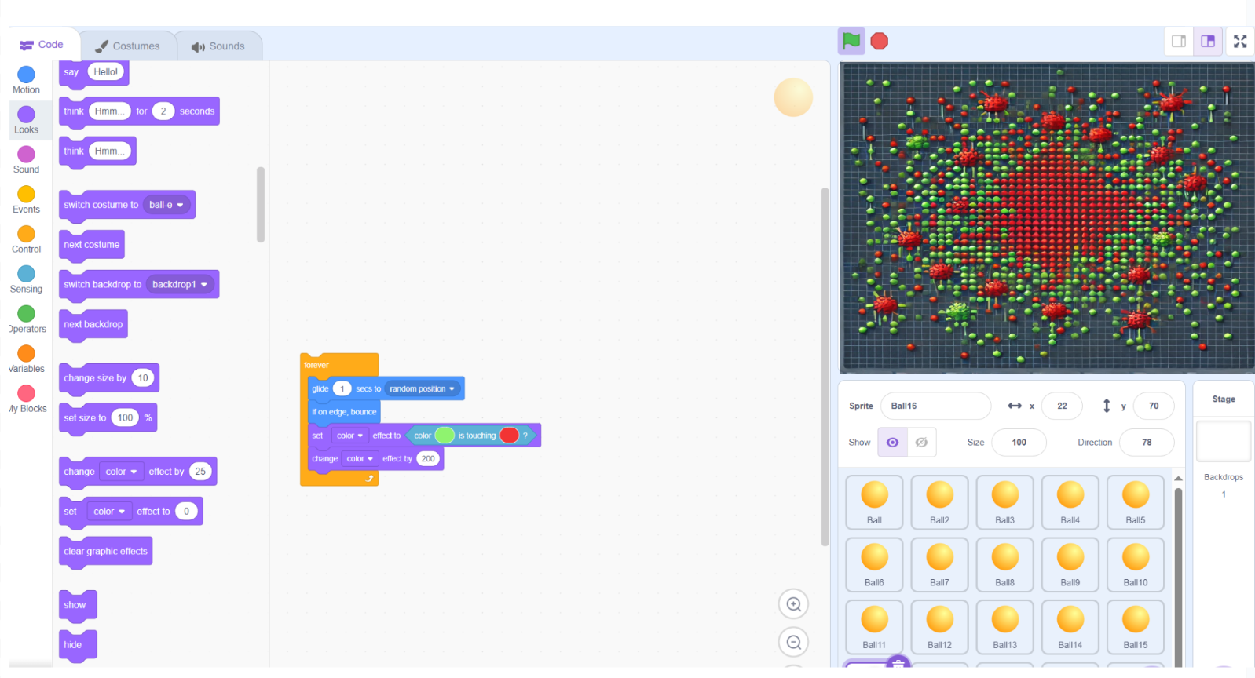

**Independent Practice**

1)After creating their model students will be tasked with creating three changes to their program that will aim to reduce the spread of the virus and three changes that will increase the spread of their virus.

Ex. students may increase the population density to increase the spread of the disease.

*Gear up (AIG)*- Students will then create hospitals, which can cure

infected cells. These students will also experiment with different

combinations. Ex. One large hospital vs. many small ones. Which

operates more effectively? These students may also experiment with

connecting other populated playfields by travel (creating virtual

continents). AIG coordinator can field their questions while the

Teacher attends other groups.

*Gear Down*-Students will have more time to complete this

assignment, as this group will not need to complete the hospital

additions and focus on the main assignment. This group along with

others will be provided with step by step instructions that they can

follow along with the teacher.

2) After the computer modeling students will have the option of completing 1 of 3 assignments.

1. Students will read first-hand accounts of survivors in

Wilmington during the time of the pandemic in 1918. Students

will then write from the perspective of the virus and explain

the conditions that made this area/ people susceptive to the

virus, and how it was treated, or prevented.

2. Students will watch a video about the 1918 pandemic and

Slide show/canva presentation on: causes, effects, lasting

implications, and prevention measures.

3. Students will compare and contrast CDC measures now

versus some of the preventative measures and advertisements

from 1918. Students will then draw and create PSA bulletin that

lists 4 measures that people in 1918 could have taken to make

themselves safer.

*Gear up (AIG)*- Students will reference their finding in the virus

simulation in their individual practice choice.

*Gear Down*-Students will have more time to complete this

assignment, the ability for choice means that these students will get

to decide which activity they feel most comfortable with.

**Closing (10 minutes)**

Frame this lesson in the global context:

· Anyone can get to any point on the inhabited continents in a

24-hr period.

· Think about if we sped up our simulation.

· What would this do to the viruses spread?

· Ebola outbreak in West Africa

· Avian (and swine) flu and livestock practices.

· Review major definitions and how they apply, relate definitions back to the computer design.

Review: After WWI why was Wilmington hit hard by the flu pandemic?

**Assessment:​** (25-30 min)

Students will present their project they created during the independent practice phase of the lesson cycle. Students must use information about the movement of viruses gathered from the computer programming portion of this lesson as well as research gathered from their independent assignment.